Koala are on the move!

 | Builders will be working on our new home at 83 High Street in July and August
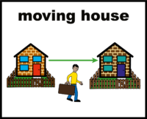  hub | But we have to move our hub while this work is being done
 | We have to move for 2 months
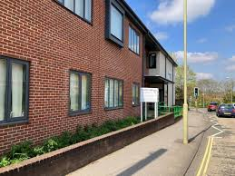 | Koala will be at Purple Oak for those 2 months
 | We will close on Monday 24th June (after adults day group) so that we can move to Purple Oak
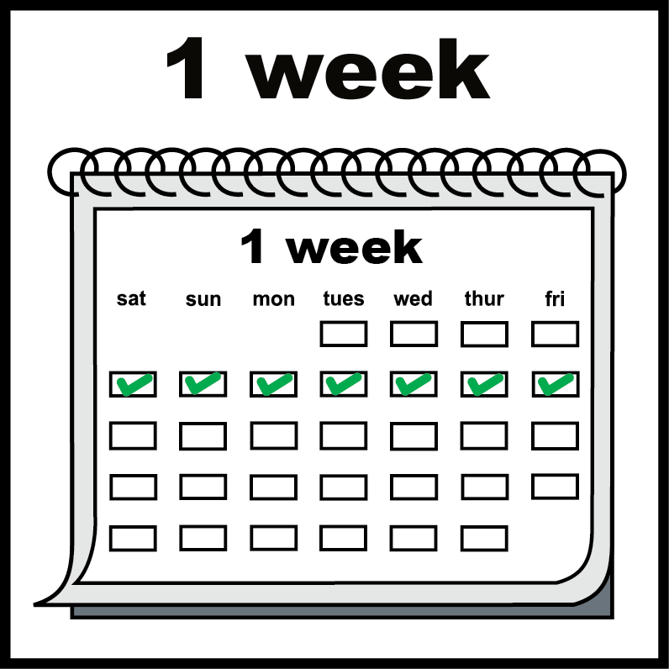 | We will be closed for 1 week
 | We will open again on Monday 1st July at Purple Oak
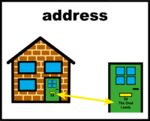 | We will have our own front door to the building
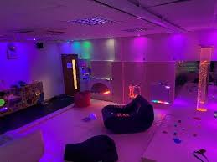 | We will be able to use their lovely sensory room
 | Purple Oak also supports disabled people so is a good place for us to be
 | We will put a video on Facebook on Thursday so that you can see the new space
 | Tori will also do a Facebook live on Thursday night so you can ask any questions
 | You can email us at hello@moreeducation.co.uk if you have questions

